Homework 3 (2007-09-21)
Submission deadline: 2007-09-30

Question 2: Consider “Academic Payroll System for University” (Introduced in Question 4 of Homework 2) and based on example on page 206 of textbook, develop a requirement analysis document which includes:

1. Identified objects (entity, boundary, control) also describe the heuristics you use.
Identify Entity Objects
We identify entity objects and their attributes by applying Abbott’s heuristics on the problem statement and the use cases defined in last homework. We focus on recurring noun phases that denotes concepts of application domain, and keep eyes on real world entities as well.
Entity Object | Attributes & Associations | Definition
AcadamicPayroll | name of university | An instance of Academic Payroll System.
Academic | name (implied) | An actor presenting teaching staff or lab researcher.
FullTimeAcadamic |  | An Academic who works full time.
CasualAcadamic |  | An Academic who works part-time according to Contract.
Employee | name (implied) | An actor presenting administrative staff under personnel department.
Leave | balance | A Leave stands for the facts that a staff is off work.
Payment | tax rate  method | A Payment is a transaction of money to staff.
Salary | amount (implied) | A Salary is the amount of money to be paid to staff.
Contract | number  hourly rate | An agreement signed by CasualAcadamic.

Identify Boundary Objects
We scan the use cases and problem statement and identify the different points where information is exchanged between the actors and the system. We focus on interfaces and notices in which the system provides information to the actors.
Boundary Object | Definition
Desktop | Windows-based desktop interface used by Employee to access AP System.
AcadamicKiock | Web-based interface used by Academic to access AP System.
PaymentNotification | Notification received by CasualAcadamic about the Payment.
TimeCard | CausualAcdemic uses TimeCard to notify AcadamicPayroll about dates and hours worked.

Identify Control Objects
Control objects represent the coordination among boundary and entity objects, we consider two use cases in this problem. In ViewPaymentDetail, we identify a single control object called ViewPaymentControl, which is responsible for collecting all history payments, and checking individual payment. In MakePayment, we identify a single control object called MakePaymentControl, which is responsible for figuring out salary, generating payment, and finally notifying user.

2. UML sequence diagrams for the problem.
Notations used in sequence diagram:
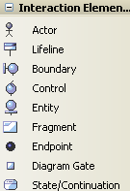

UML sequence diagram for ViewPaymentDetail use case
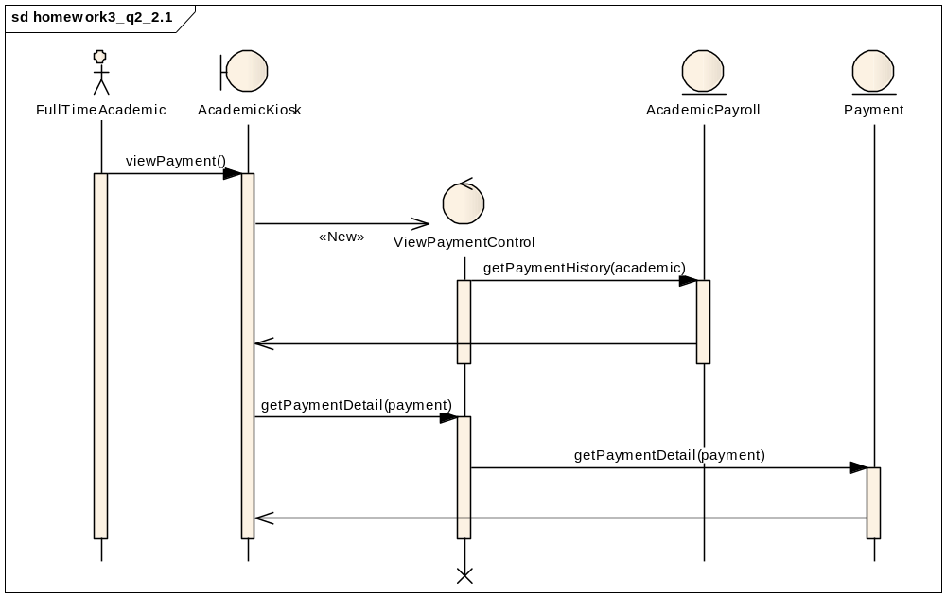
When requesting payment details, the control object must first obtain a list of (history) payments. It requests from the AcademicPayroll class, which maintains the list of (history) payments. Then for each payment, the control object consults the Payment class for details.

UML sequence diagram for MakePayment use case
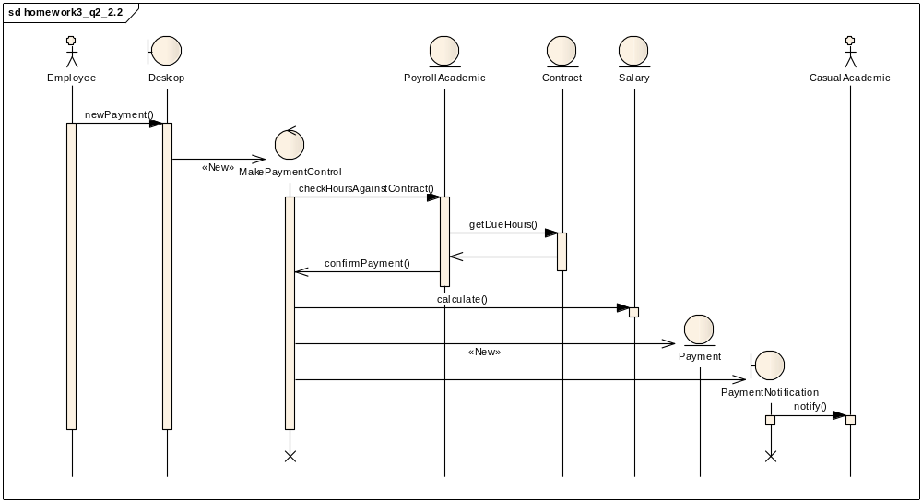
When making new payment, the control object first verifies working hours in Contract via PayrollAcademic, and calculates the corresponding salary, then creates a new instance of Payment entity, finally it produces a new boundary object PaymentNotification to notify CasualAcdemic about the arrival of new payment.

3. UML class diagrams for the problem.
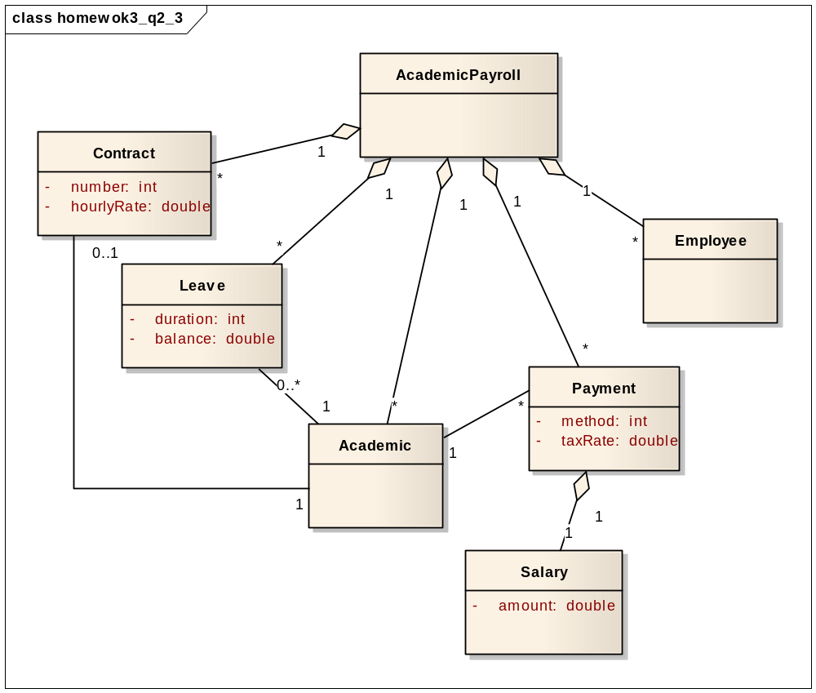
In this UML class diagram, we focus on associations only.
AcademicPayroll tracks a list of all Conrtacts, Leaves, Academics, Payments and Employees. An Academic has no Leave (full-time Academic) or more than one Leaves (part-time Academic), only part-time Academic has a Contract, and An Academic has many Payments, where each Payment contains a piece of Salary.

4. Inheritance hierarchy among entity objects.
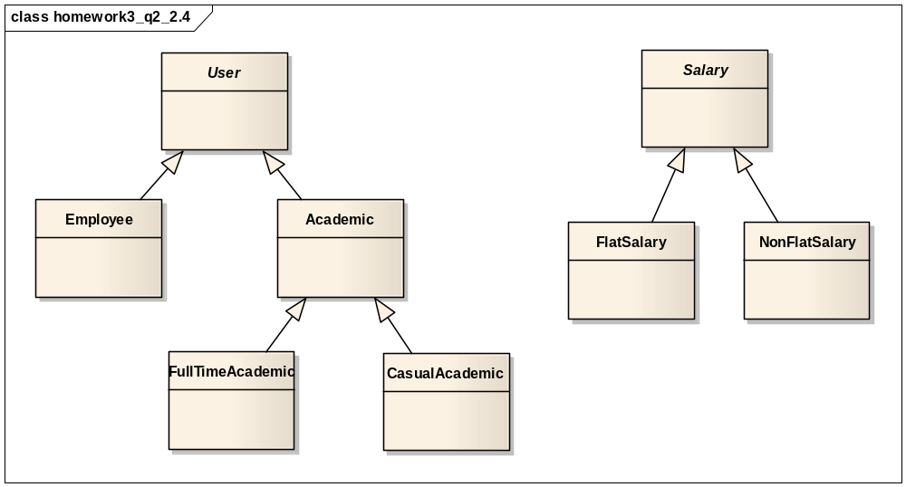
First, we identify an abstract class User through generalization, Employee and Academic are two types of User who access AcademicPayroll system differently, FullTimeAcademic and CasualAcademic are kinds of Academic having distinct Salary, FlatSalary for FullTimeAcademic while NonFlatSalary for CasualAcademic.

Question 4: Consider the problem description for “Advert Consultancy Inc” (Introduced in Question 5 of Homework 2) and based on example on page 206 of textbook, develop a complete requirement analysis document which should include:

1. Identified entity objects.

2. Identified boundary objects.

3. Identified control objects.

4. Map the use cases you developed in Homework 2 to identified objects with sequence diagrams.

5. UML class diagrams.

6. Inheritance relationships among objects identified in step 1-3.

7. State-chart diagrams for objects identified in step 1-3.

